

University Human Resources
Townsend Hall, South Campus
(716) 645-7777
UB-ClassandComp@buffalo.edu
The University at Buffalo

Instruction Manual

Line Assignment Application

Contents
Single Line Search Panel 5
Effective Date 6
Title 7
Additional Attributes 9
Search Results Panel 12
Line Account Association Panel 13
Add Additional Accounts 14
Remove Additional Accounts 15
Single Line Search Summary 16
Appendix 1 17
Additional Information 17
Department Benefits: 17
Need to know: 17
When to contact Human Resources: 17
How to gain access to the line assignment application: 17
Appendix 2 18
Pay Basis Definitions 18

Single Line Search Panel
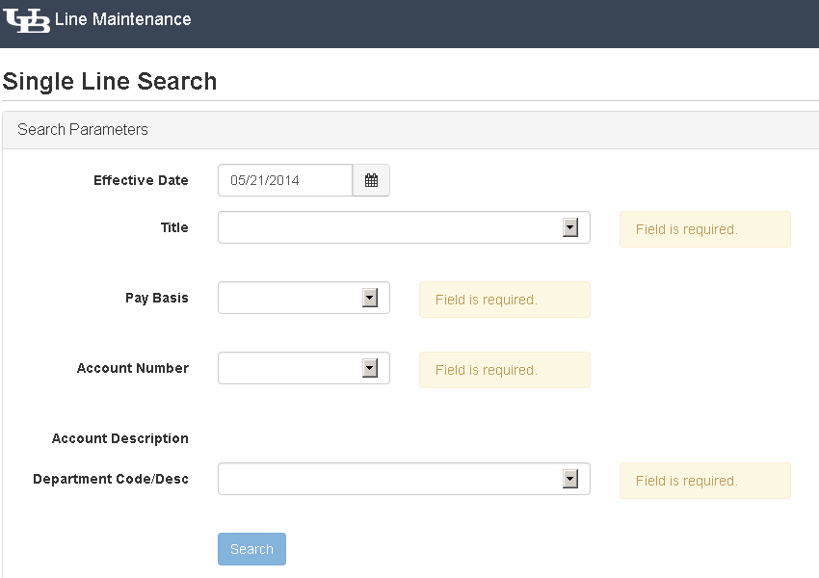
1

2

3

Action | Field Description
1 | The Single Line Search panel gives you the flexibility to search and obtain a line for use in UB Jobs and/or e-PTF. The single line search panel is a smart form meaning that as you populate the form; your options for the next fields are customized showing you only valid values.
2 | Information that you must provide is denoted with a Field is required box to the right of the field.
3 | Once you have populated all the required fields, the Search button will be activated to allow you to select your line.

Effective Date
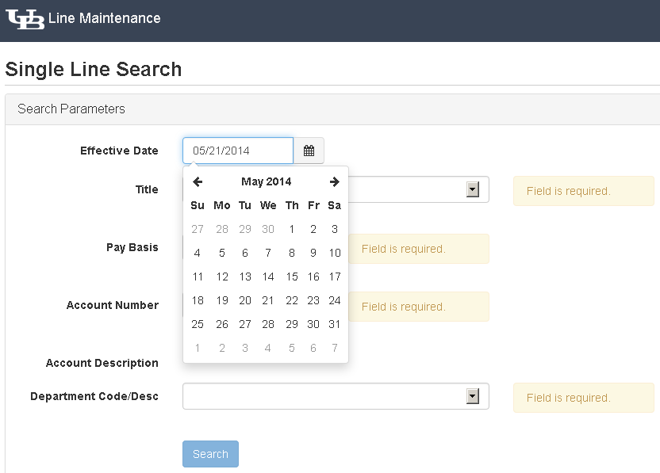

2
3
1

4

Action | Field Description
1 | The first attribute to be populated is the Effective Date for the line. In this field, you will want to select the anticipated date that this line will be used. If you are creating a UB Jobs action, you will want to use the current date. If you are processing an e-PTF, you will need to use the effective date of your appointment.
2 | The effective date is defaulted to today’s date. To make modifications to this date, Click on the Calendar to the right of the date field.
3 | Using the arrows next to the Month and Year, you will be able to navigate to past and future dates.
4 | Once you have the desired Month and Year, you will click on the appropriate Day within the calendar.  Please note: You can select any previous date that corresponds with the appointment you are creating. You cannot select a future date that will be more than 120 days.

Title
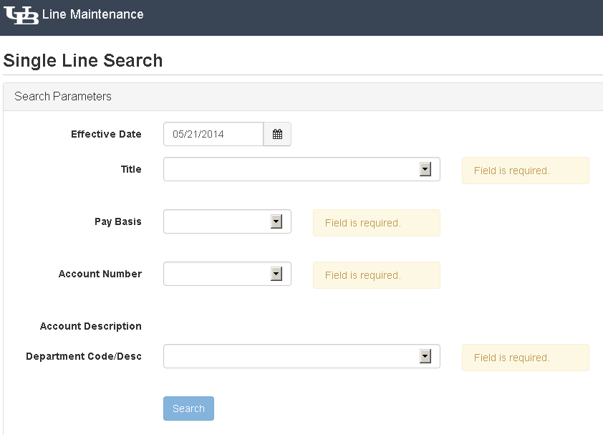

2
1

Action | Field Description
1 | Next you are going to select the Title of the position that you are creating.
2 | You can click anywhere in the field or on the arrow to the right of the field to view a list of approved official state titles.

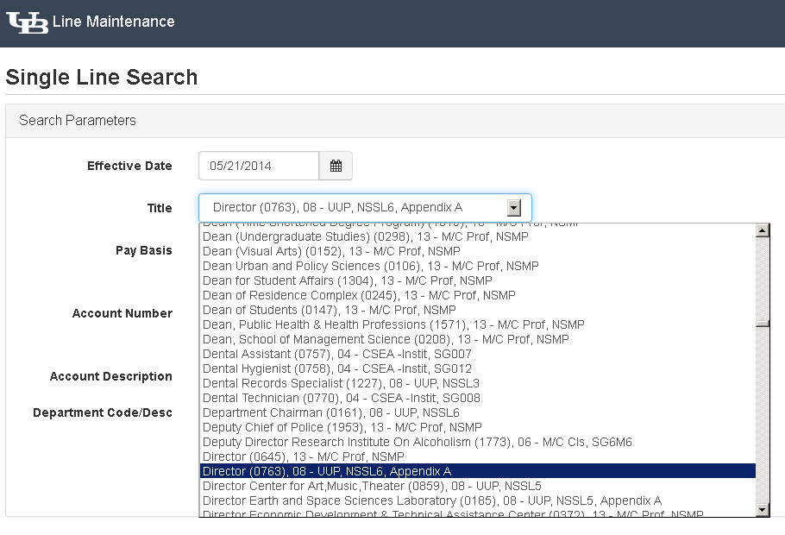

1

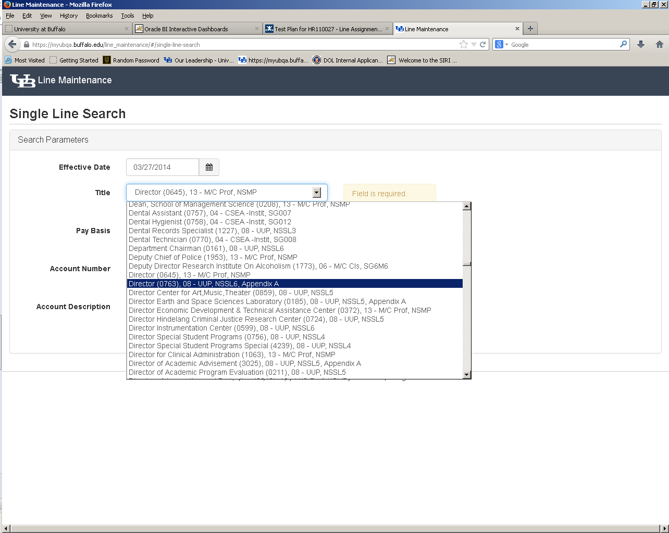

7
5
6
4
3

Action | Field Description
1 | The title list is in alphabetical order. You can navigate this list by using the up and down arrows to the right of the title list or you can start typing the title.
2 | Each title contains detailed information about the position including:
3 | - Official Title
4 | - OEC Code
5 | - Negotiating Unit
6 | - Salary Grade
7 | - Indicator if the title is an appendix A, B or C title.

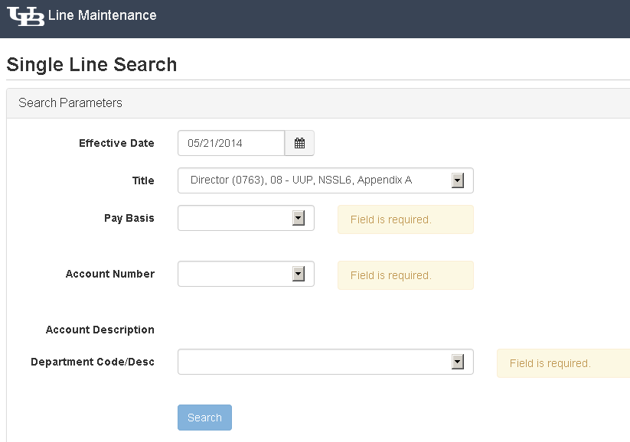
Additional Attributes

1
2

4
3

Action | Field Description
1 | Based on the title selected, you will choose a valid pay basis for the position.
2 | You will always be required to provide an account number to put a hold on the line. The drop down list of account numbers shows all accounts for which you are an authorized user.
3 | The account description will automatically be populated based on the account number selected.
4 | You will select the department for this position.

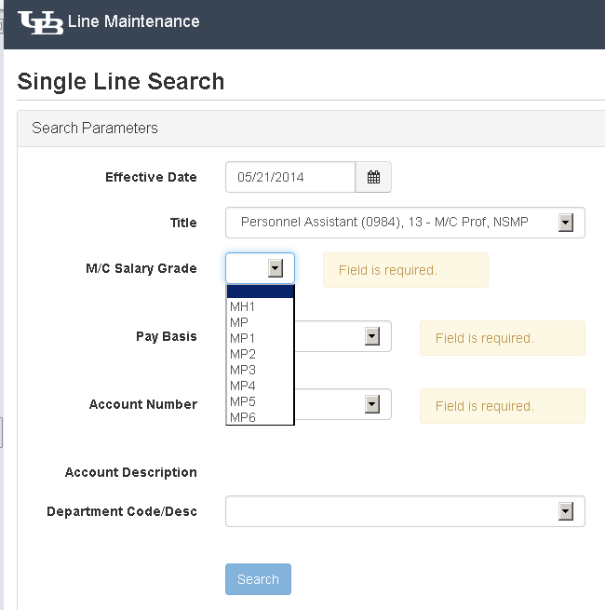

1

Action | Field Description
1 | For MC positions, you will be required to provide the M/C Salary Grade.

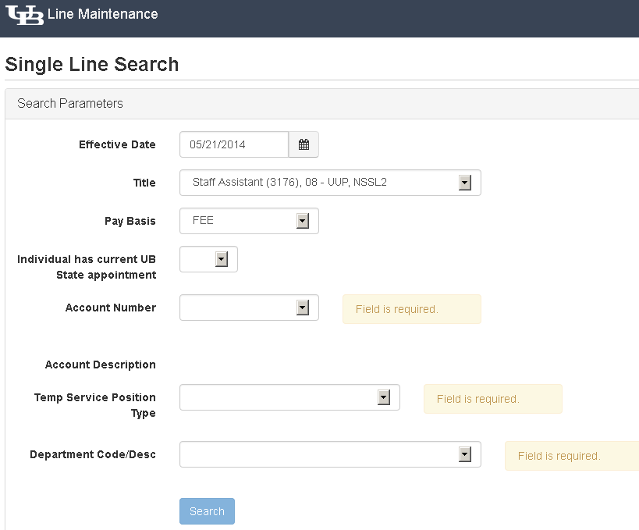

2
1

3

Action | Field Description
1 | When a FEE Pay Basis is selected, you will be required to indicate whether or not this line is for a current employee.  - For current employees, a new line number is not required and you will be prompted to use the employee’s existing line.  - For new employees, you will be able to continue with your request for a line.
2 | When a temp service pay basis is selected such as HRY, FEE, BIW, you will be prompted to tell us the temp service position type.  - Biweekly Adjunct (Regular Academic Year) – to be used when you are hiring an Adjunct Instructor for the Fall and/or Spring semesters.  - Extra Service – to be used as compensation for work performed by faculty and staff at UB that primarily work at a difference agency.  - Fee - to be used as a method of payment that allows periodic payments of varying amounts based upon the completion of some measurable unit of work/accomplishment.  - Hourly – to be used when paying at an hourly rate for hours worked.  - Scholarship Recipient – HR use only. To be used for financial aid for Students.  - Student Assistant – to be used for SUNY students who are employed on temporary service and paid on an hourly basis.  - Summer and Winter Appointments – to be used for Summer and Winter appointments only.  - TA/GA – to be used anytime the position is a teaching or graduate assistant.  - Union –To be used for skilled trade non-state employees only.
3 | Once the form is complete, you will be able to click the Search button allowing you to move forward with your request.
4 | If at any time, the prompts are not applicable to the position that you are trying to create, please review the title and it’s attributes as well as the pay basis selected. These two pieces of information prompt the additional questions asked in the application.

Search Results Panel
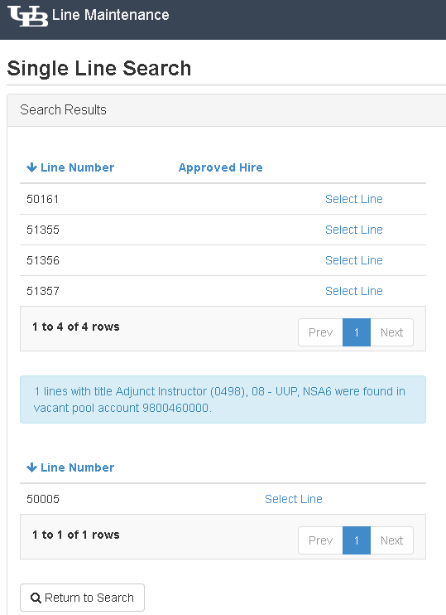

1
2
3

4

5

6

Action | Field Description
1 | On the Search Results panel, you are shown all vacant lines that meet the criteria entered on the previous page currently assigned to the account number. If no vacant lines exist in the account, a message will be displayed: No line matching specified criteria found in departmental account XXXXXXXXXX.
2 | The Approved Hire column will show the UB Jobs approved hire affiliated with the vacant line number.
3 | To utilize a line that already exists; you will click on the Select Line link next to the corresponding line.
4 | The search results panel will only display 10 lines at a time. To view additional lines, click on the Next button.
5 | If no lines are available or the existing vacant lines should not be used for this action, you will click on Select Line using the line from the vacant pool.
6 | To cancel your search, click on Return to Search.

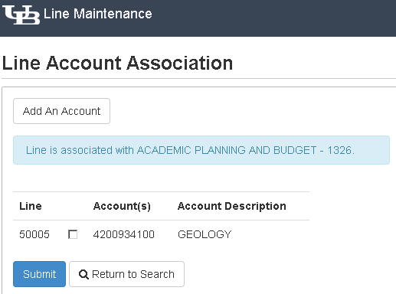
Line Account Association Panel

1

2
Sample Department Name

Sample Account 1
1234567898

4
3

Action | Field Description
1 | On the Line Account Association panel, you are shown the line number selected; the account number assigned to the account from the title attributes page and the account description affiliated with that account.
2 | To add additional account numbers affiliated with this position, you will click on Add an Account.
3 | When all account information has been added, you can click on Submit.
4 | To cancel your search, you will click on Return to Search.

Add Additional Accounts
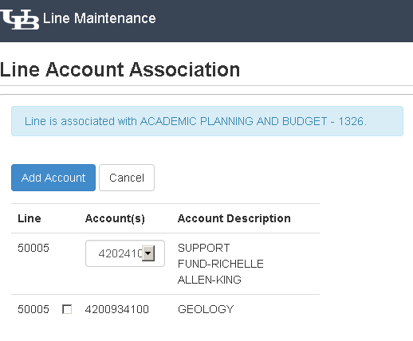

Sample Department Name
3
1

2
Sample Account 2
987654321

123456789
Sample Account 1

Action | Field Description
1 | If Add an Account was selected in error, you can click on Cancel to be brought back to the Line Account Association panel to submit your line request.
2 | To continue with the addition of another account, you will click on the arrow next to the account drop down and select an account number from the list of accounts you are authorized to access.
3 | To accept the additional account, you will click on Add Account.

Remove Additional Accounts
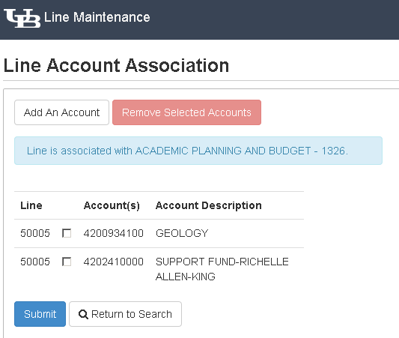

Sample Department Name
1

Sample Department 2
987654321
Sample Department 1
123456789

2
3
Action | Field Description
1 | When an account is selected in error, click on the checkbox to the left of the account number and select Remove Selected Accounts. Please note: you will be required to have at least one account number at all times on this panel.
2 | If you wish to cancel your request at this time, click on the Return to Search button.
3 | To continue with your search, click Submit.

Single Line Search Summary
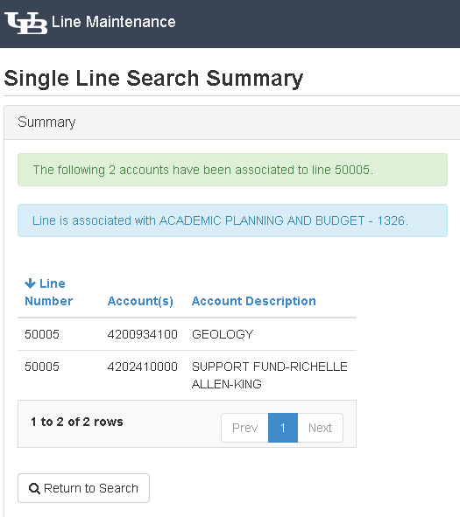

1

Sample Department Name

987654321
Sample Account 2
123456789
Sample Account 1

2

Action | Field Description
1 | The Single Line Search Summary displays the line number assigned, the account number and account description affiliated with the line number. This line is now available for use in the UB Jobs and/or e-PTF system.  Please note: You must either complete your UB Jobs transaction or process your e-PTF within 120 days of obtaining this line or it will be returned to the vacant line pool.
2 | To set up another line, click on Return to Search.

Appendix 1

Additional Information

Department Benefits:
- Lines are immediately available for e-PTF and posting submission.
- A better process to manage line to account associations.
- Stability in accounts.

Need to know:
- Unused lines will remain in your account for 120 days.
- Reports are available in SIRI showing vacant lines in your account and their expiration dates.
- Funding is not associated with the line you are assigned until a budget revision is processed.
- When using the Line Assignment System, you should have prior unit approvals for requesting the line and ensure your account/unit has sufficient funding approved for the line being requested.

When to contact Human Resources:
- Multiple lines with the same title, pay basis, account number and department need to be created.
- You need to retain a line that will have no action taken within 120 days.
- You want to return a line to the vacant line pool before the 120 days.

How to gain access to the line assignment application:
- To request access, complete the Employee Access Data Request Form http://hr.buffalo.edu/files/phatfile/Data_Access_Request.pdf.
- Please visit www.myub.buffalo.edu/Line_maintenance/ to access the line assignment application.

Appendix 2

Pay Basis Definitions

ANN – Annual
Professional, Classified and Faculty employees with a 12-month obligation who are paid over 26 pay periods

BIW – Biweekly
Adjunct Instructors and TA/GA’s paid on a bi-weekly basis

CAL – Calendar Year
Faculty with a 10-month obligation who are paid over 26 pay periods

CYF – College Year Full
Professional employees with a 10-month obligation paid over 26 pay periods

FEE – Fee
Employees paid on a Fee basis including, Student Assistants, Scholarship Recipients, Summer and Winter Appointments, Fee employees and Extra Service appointments

HRY – Hourly
Non-student employees paid on an hourly basis

21P
Faculty with a 10-month obligation who are paid over 21 pay periods

